**GOVERNOR STIRLING SENIOR HIGH SCHOOL**

**HUMAN BIOLOGY YEAR 11 ATAR**

**TASK 10: DNA, CELL REPRODUCTION & HUMAN REPRODUCTION**

**SECTION A: MULTIPLE CHOICE (30 MARKS):**

1. At which stage of meiosis does genetic recombination, or crossing over, occur?
   1. Prophase I
   2. Prophase II
   3. Metaphase I
   4. Metaphase II
2. A bacterial culture contains methyl-labelled thymine (T^). The culture is transferred to a solution containing unlabelled thymine, and after one round of replication the DNA is analysed. Which of the following could be representative of the analysed DNA?
   1. T^ T A A C G

A A T^ T G C

* 1. T^T^A A C G

A A T T G C

* 1. T T A A C G

A A T T G C

* 1. T^T^A A C G

A A T^ T^ G C

1. The following diagram shows the changes in the thickness of the uterine lining of a woman during a menstrual cycle. On what day would the woman be most fertile?

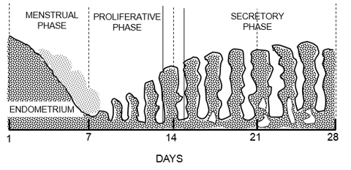

1. Day 7
2. Day 14
3. Day 21
4. Day 28
5. At which phase of cell division can we observe the following diagram?

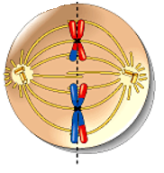

1. metaphase 1 of meiosis
2. metaphase 2 of meiosis
3. anaphase 1 of mitosis
4. anaphase 2 of meiosis
5. The dominant hormone controlling the secretory phase of the menstrual cycle is
6. progesterone
7. follicle-stimulating hormone (FSH)
8. luteinizing hormone (LH)
9. human chorionic gonadotropin (HCG)

Refer to the following table for Questions 6 and 7.

The table shows the amino acid and the corresponding mRNA codons.

**mRNA codons for 6 amino acids**

|  |  |
| --- | --- |
| **Amino Acid** | **Codon** |
| Alanine | GCA |
| Leucine | UUG |
| Methionine | AUG |
| Arginine | CGU |
| Histidine | CAU |
| Tyrosine | UAC |

1. What is the base sequence on a DNA molecule that will allow the amino acid arginine to be incorporated into the polypeptide chain?
2. GCT
3. CGU
4. CGA
5. GCA
6. Transfer RNA has a role in the translation of polypeptides. Which amino acid would be carried to the ribosome by transfer RNA with the anti-codon CGU?
7. arginine
8. alanine
9. histidine
10. methionine
11. A cell in the germinal epithelium of the seminiferous tubules has 46 chromosomes. Which of the following indicate the correct number of chromosomes in a primary spermatocyte, a secondary spermatocyte and a spermatid?

|  |  |  |  |
| --- | --- | --- | --- |
|  | **Primary spermatocyte** | **Secondary spermatocyte** | **Spermatid** |
| (a) | 46 | 23 | 23 |
| (b) | 92 | 46 | 23 |
| (c) | 46 | 23 | 46 |
| (d) | 46 | 46 | 46 |

Question 9 refers to the diagrams below which show two stages of mitosis in cells.

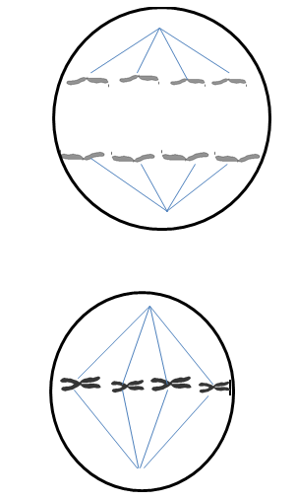

Diagram 2

Diagram 1

1. Diagram 1 and 2 can be represented by which of the two sentences provided?

|  |  |  |
| --- | --- | --- |
|  | **Diagram 1** | **Diagram 2** |
| (a) | Chromatids are pulled to opposite ends of the cell | Chromosomes line up at the centre of the cell |
| (b) | Nuclear membrane reforms | Chromosomes line up at the centre of the cell |
| (c) | Chromatids are pulled to opposite ends of the cell | Chromosomes shorten and thicken |
| (d) | Chromosomes shorten and thicken | Chromosomes line up at the centre of the cell |

1. Which of the following is the correct order of structures through which sperm pass during ejaculation?
2. Urethra, vas deferens, epididymis
3. Epididymis, vas deferens, urethra
4. Vas deferens, urethra, epididymis
5. Vas deferens, seminiferous tubules, urethra
6. The atypical growth and spread of abnormal cells is known as:
7. cancer
8. carcinogen
9. biopsy
10. malignant
11. Which of the following statements is **INCORRECT?** Two cells which are the result of mitosis
    1. Have identical genetic potential
    2. Will develop identically
    3. Have the same chromosome number as each other
    4. Contain chromosomes that are not duplicated
12. Messenger RNA leaves the nucleus and attaches to a
13. Ribosome
14. Golgi apparatus
15. Mitochondrion
16. Cell membrane
17. Inheritance of mitochondrial DNA
18. Is dependent on having DNA input from both parents
19. Is inherited through the father
20. Is inherited through the mother
21. Is randomly inherited from either parent
22. Which of the following statements is **correct**?

In the process of meiosis, the cells produced are:

1. identical with the same number of chromosomes as the parent cell.
2. identical with half the number of chromosomes as the parent cell.
3. not identical with the same number of chromosomes as the parent cell.
4. not identical with half the number of chromosomes as the parent cell.
5. The diagram below shows some of the events during the process of meiosis

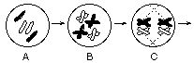

Which of the following diagrams represents a new cell that could be produced by this type of cell division?

|  |  |
| --- | --- |
| (a) | le_rep_dev_review_files/i0100001.jpg |
| (b) | le_rep_dev_review_files/i0100002.jpg |
| (c) | le_rep_dev_review_files/i0100003.jpg |
| (d) | le_rep_dev_review_files/i0100004.jpg |

1. Which of the following is **not** a source of variation in humans?
2. Differentiation
3. Crossing over
4. Non-disjunction
5. Random assortment
6. The following is a list of techniques used in the diagnosis of cancer. Which would **not** be routinely used to help diagnose breast cancer?
7. biopsy
8. endoscopy
9. ultrasound
10. radiology
11. Which of the following is **not** a potential carcinogen?
    1. Alcohol
    2. Cigarette smoke
    3. Ultraviolet light
    4. Visible light
12. After the corpus luteum degenerates, the thickened endometrium is no longer maintained. This results in
13. ovulation
14. menstruation
15. pregnancy
16. sterilization
17. In the human male the testes are suspended in the scrotum outside the body, as a result they are
18. better protected
19. kept free from antibodies
20. given better support
21. at a lower temperature
22. The physiology of the menstrual cycle in human females is usually controlled by
23. the type of food eaten
24. enzymes produced in the ovary
25. hormones released from the placenta
26. hormones released from the pituitary gland

**Question 23 refers to the graph shown below.**

1. 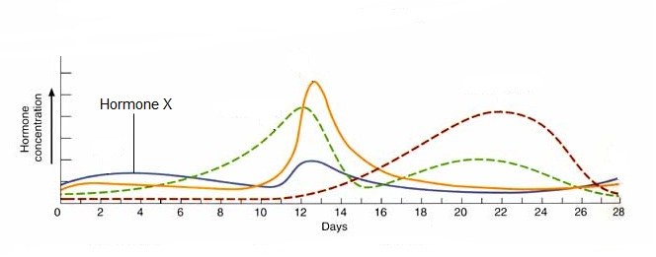The graph shows the hormonal changes during the female menstrual and ovarian cycles. Which hormone is best represented by hormone X?
   1. progesterone
   2. luteinising hormone
   3. oestrogen
   4. follicle stimulating hormone
2. Which of the following is **NOT** correctregarding spermatogenesis?
3. it begins before birth then ceases until after puberty
4. it occurs continually after puberty
5. the process takes about 72 days
6. one spermatogonium results in four viable spermatozoa
7. Which of the following structures is **NOT** associated with the transfer of gametes and the process of fertilization in humans?
   1. vas deferens
   2. oviduct
   3. ureter
   4. uterus

**GOVERNOR STIRLING SENIOR HIGH SCHOOL**

**HUMAN BIOLOGY YEAR 11 ATAR**

**TASK 10: DNA, CELL REPRODUCTION & HUMAN REPRODUCTION**

**NAME:**

**SECTION A: MULTIPLE CHOICE: (25 MARKS):**

***Read the question carefully, select the best of the options, a, b, c or d and then place a cross in the appropriate box on the answer sheet.***

|  |  |  |  |  |  |  |  |  |  |  |
| --- | --- | --- | --- | --- | --- | --- | --- | --- | --- | --- |
| Question  Number | Answer | | | |  | Question  Number | Answer | | | |
| 1 | A | B | C | D |  | 14 | A | B | C | D |
|  |  |  |  |  |  |  |  |  |  |  |
| 2 | A | B | C | D |  | 15 | A | B | C | D |
|  |  |  |  |  |  |  |  |  |  |  |
| 3 | A | B | C | D |  | 16 | A | B | C | D |
|  |  |  |  |  |  |  |  |  |  |  |
| 4 | A | B | C | D |  | 17 | A | B | C | D |
|  |  |  |  |  |  |  |  |  |  |  |
| 5 | A | B | C | D |  | 18 | A | B | C | D |
|  |  |  |  |  |  |  |  |  |  |  |
| 6 | A | B | C | D |  | 19 | A | B | C | D |
|  |  |  |  |  |  |  |  |  |  |  |
| 7 | A | B | C | D |  | 20 | A | B | C | D |
|  |  |  |  |  |  |  |  |  |  |  |
| 8 | A | B | C | D |  | 21 | A | B | C | D |
|  |  |  |  |  |  |  |  |  |  |  |
| 9 | A | B | C | D |  | 22 | A | B | C | D |
|  |  |  |  |  |  |  |  |  |  |  |
| 10 | A | B | C | D |  | 23 | A | B | C | D |
|  |  |  |  |  |  |  |  |  |  |  |
| 11 | A | B | C | D |  | 24 | A | B | C | D |
|  |  |  |  |  |  |  |  |  |  |  |
| 12 | A | B | C | D |  | 25 | A | B | C | D |
|  |  |  |  |  |  |  |  |  |  |  |
| 13 | A | B | C | D |  |

**SECTION B: WRITTEN SECTION (30 MARKS):**

26.

1. What is epigenetics? (1 mark)

1. List two environmental factors that may cause epigenetic changes in the DNA. (2 marks)

These diagrams show the DNA of men and women who are usually sedentary (inactive). Their DNA was then examined after they experienced a period of intense exercise. The diagram below shows images of the changes in the methylation of DNA after intense exercise for 6 months.

*(Source:* [*http://www.frontiersin.org/files/Articles/68784/fgene-04-00219-r2/image\_m/fgene-04-00219-g001.jpg*](http://www.frontiersin.org/files/Articles/68784/fgene-04-00219-r2/image_m/fgene-04-00219-g001.jpg)*)*

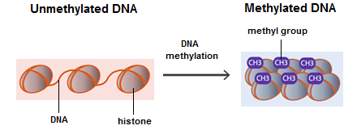

c. DNA methylation was increased in skeletal muscle biopsies obtained from sedentary men and women after intense exercise.

1. Describe the changes in the DNA (2 marks)

1. Explain how these changes affect gene expression. (2 marks)

c. Using your understanding of epigenetics, explain why identical twins are preferred subjects for research rather than fraternal twins and why twins are chosen for study cover a large span of ages. (2 marks)

d. How is epigenetic influence different from genetic influence? (2 marks)

27. The diagram below represents the female reproductive system and the events leading up to the formation of an embryo.

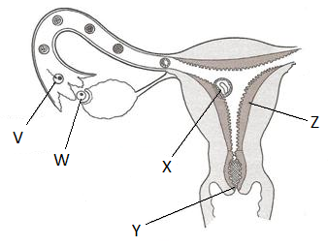*(Source:* [*http://www.naturalfamilyplanning.ie/wp-content/uploads/2008/05/transport.jpg*](http://www.naturalfamilyplanning.ie/wp-content/uploads/2008/05/transport.jpg)*)*

a. Name the following structures: (2 marks)

Y \_\_\_\_\_\_\_\_\_\_\_\_\_\_\_\_\_\_\_\_\_\_\_\_\_\_\_\_\_\_\_\_\_\_\_\_\_\_\_\_\_\_\_\_\_\_

Z \_\_\_\_\_\_\_\_\_\_\_\_\_\_\_\_\_\_\_\_\_\_\_\_\_\_\_\_\_\_\_\_\_\_\_\_\_\_\_\_\_\_\_\_\_\_

b. Name the process occurring at **W** and describe the hormonal trigger for this process. (2 marks)

28. The diagram below shows a DNA molecule. (3 marks)

*(Source:* [*http://bioserv.fiu.edu/~walterm/human\_online/organic/img030.gif*](http://bioserv.fiu.edu/~walterm/human_online/organic/img030.gif)*)*

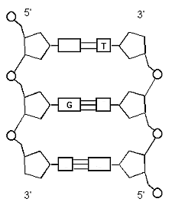

1. Use arrows to label the **deoxyribose sugar** and the **phosphate** on the diagram.
2. Name the complimentary base that binds to **Thymine**
3. Name the complimentary base that binds to **Guanine**

29. Complete the table below for ***human cells:*** (5 marks)

|  |  |  |
| --- | --- | --- |
|  | **Mitosis** | **Meiosis** |
| *What is the purpose of this type of cell division* |  |  |
| *How many chromosomes are there in the parent cell?* |  |  |
| *How many times does the cell divide?* |  |  |
| *Where does the process occur in the human body?* |  |  |
| *How many chromosomes are in the daughter cells produced?* |  |  |

30. What are the differences between the cell divisions involved in spermatogenesis and oogenesis? (2 marks)

31. The following questions refer to the process of Protein Synthesis.

1. Describe the role of mRNA in protein synthesis. (2 marks)

1. Describe the process of translation. (3 marks)

***END OF TEST***

***TOTAL = 55 MARKS***